Automated Teller Machine(ATM)

**Introduction:**

The term ATM is Abbreviated for Automated Teller Machine. ATM is a Networked Embedded system. The ATM machine was implemented to reduce the obstructions of the branch networking by reaching out to the customers by offering comfortable services with fewer transaction charges. After that, many improvements in this technology have arrived and also customer accessibility has also improved through boundaries.

ATM is an electronic device that is used by bank customers to process account transactions. The users access their accounts through a special type of plastic card that is encoded with user information on a magnetic strip. The strip contains an identification code that is transmitted to the bank’s central computer by modem. The users insert the card into ATMs to access the account and process their account transactions.

**Services Offered**:

By using an automated teller machine or ATM we can perform different financial transactions such as cash deposits, withdrawals, transfer funds, information of account, ATM PIN change, and also linking the Aadhaar number to the bank account so that the interaction between the bank staff and the customer can be reduced.

**Architecture:**

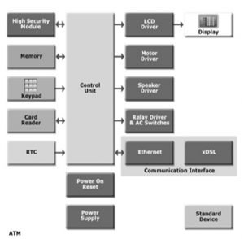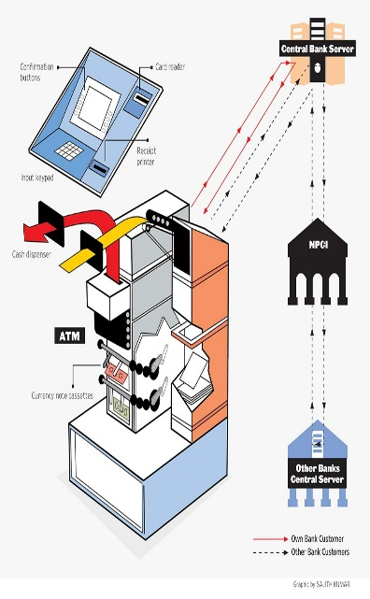

**Input Devices:**

Card Reader:

The card reader is an input device that reads data from a card. The card reader is part of the identification of your particular account number and the magnetic strip on the backside of the ATM card is used for connection with the card reader. The card is swiped or pressed on the card reader which captures your account information i.e. the data from the card is passed on to the host processor (server). The host processor thus uses this data to get the information from the cardholders.

Keypad:

The card is recognized after the machine asks for further details like your identification number, withdrawal, and your balance inquiry Each card has a unique PIN so that there is little chance for some else to withdraw money from your account. There are separate laws to protect the PIN code while sending it to the host processor. The PIN is mostly sent in encrypted form. The keyboard contains 48 keys and is interfaced to the processor.

**Output Devices:**

• Speaker – When a particular key is pressed, the speaker provides the feedback as audio.

• Display Screen – The questions asked by the ATM machine regarding the transaction and the input from the user is all displayed on the display screen. Each step of withdrawal is shown by the display screen. A CRT screen or even an LCD screen is commonly used as an LCD screen.

• Receipt printer – All the details regarding your withdrawal like the date and time and the amount withdrawn and also the balance amount in the bank is also shown in the receipt. Thus a paper receipt of the current transaction is obtained by the user.

• Cash dispenser – This is the central system of the ATM machine. This is from where the required money is obtained. From this portion the person can collect the money. The cash dispenser must count each bill and give the required amount. If in some cases the money is folded, it will be moved to another section and becomes the reject bit. All these actions are carried out by high precision sensors. A complete record of each transaction is kept by the ATM with the help of an RTC device.

**Working:**

It is an electronic device that is used by only bank customers to process account transactions. The users access their accounts through a special type of plastic card that is encoded with user information on a magnetic strip. The strip contains an identification code that is transmitted to the bank’s central computer by modem. The users insert the card into ATMs to access the account and process their account transactions.

**ATM Networking**

When a transaction is made, the details are inputted by the card holder. This information is passed on to the host processor by the ATM machine. The host processor checks these details with the authorized bank.  If the details are correct, the requested cash by the card holder is taken with the help of an electronic fund from the customer’s bank account to the host processor’s account. After this function is carried out, the processor sends an approval code to the ATM machine so that the cash can be transferred.

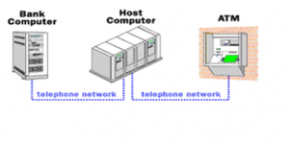

**Conclusion:**

Advantages:

1..Less time required

2..No Documentation required

3..24/7 service

Disadvantages:

1.Theft

2.Security

3.Maintenance

**Resources:**

1.<https://www.elprocus.com/automated-teller-machine-types-working-advantages/>

2. <https://www.circuitstoday.com/working-of-automatic-teller-machine-atm>

3. <https://www.techulator.com/experts/3526-How-does-an-ATM-work>